**AWS Data Migration Service (DMS)**

**On-premises DB aws DB Instances**

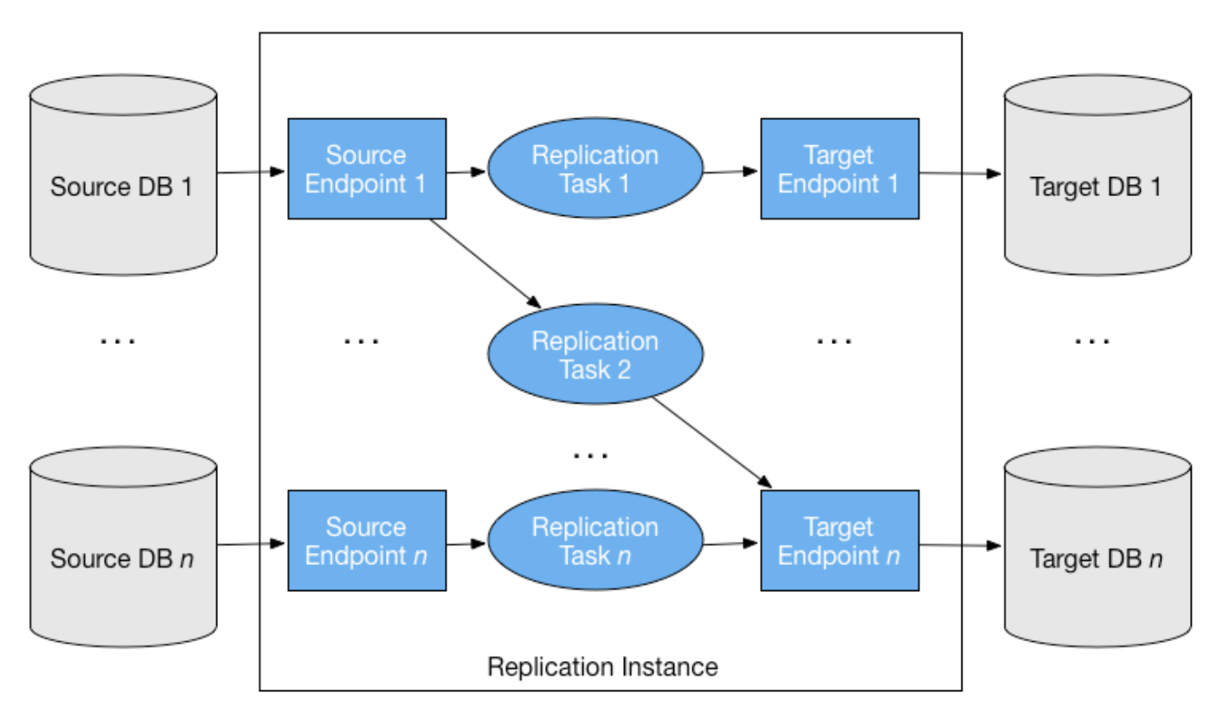

* AWS Data Migration Service (DMS) is a fully managed cloud service provided by Amazon Web Services (AWS) that facilitates the migration of data between various data storage systems. It allows seamless and secure movement of data from on-premises databases to the AWS cloud, between different AWS services, or even between different database platforms within the cloud.
* AWS DMS handles various types of data migration tasks, including one-time full load migrations and continuous data replication with change data capture (CDC). With DMS, you can transfer data with minimal downtime, ensuring that your source and target systems remain synchronized.
* The service offers an intuitive web-based console for setting up, monitoring, and managing migration tasks. It supports a wide range of source and target endpoints, including Amazon RDS (Relational Database Service), Amazon S3 (Simple Storage Service), Amazon Redshift, and more, making it versatile for diverse data migration scenarios.

# Table of Contents

1. Introduction to AWS Data Migration Service (DMS)

2. Key Features of AWS Data Migration Service

3. Supported Data Migration Scenarios

4. Components of AWS Data Migration Service

5. How AWS Data Migration Service Works

6. Getting Started with AWS Data Migration Service

- Prerequisites

- Steps to Set Up AWS DMS

7. Creating and Managing DMS Tasks

- Source and Target Endpoints

- Replication Instance

- Task Creation and Configuration

- Monitoring and Managing DMS Tasks

8. Best Practices for AWS Data Migration Service

9. Security and Compliance Considerations

10. Troubleshooting AWS DMS

11. Cost Optimization Strategies

12. Limitations and Known Issues

13. Conclusion

# 

# 1. Introduction to AWS Data Migration Service (DMS)

AWS Data Migration Service (DMS) is a fully managed cloud service provided by Amazon Web Services (AWS) that allows organizations to migrate and replicate data seamlessly between various data sources and target databases. It simplifies and accelerates the process of moving data from one location to another, whether it's within AWS or to an external database.

With AWS DMS, users can migrate data from on-premises databases to the cloud, from one cloud database to another, or even perform continuous replication between different databases to ensure data consistency and availability. The service supports a wide range of databases, making it versatile and flexible for various data migration scenarios.

# 2. Key Features of AWS Data Migration Service

**Fully Managed Service:** AWS DMS is fully managed by AWS, which means AWS takes care of all the infrastructure and maintenance tasks, allowing users to focus on the data migration process.

**Database Compatibility:** AWS DMS supports a broad array of source and target databases, including Amazon RDS, Amazon Aurora, Amazon Redshift, on-premises databases, and third-party databases such as Oracle, SQL Server, MySQL, PostgreSQL, and more.

**Highly Available and Scalable:** AWS DMS ensures high availability and scalability, automatically scaling resources based on the workload demands.

**Data Validation and Transformation:** DMS offers options to validate and transform data during the migration process to ensure data integrity and consistency between source and target databases.

**Real-time Data Replication:** Users can perform real-time data replication for continuous data synchronization between databases.

**CDC (Change Data Capture):** AWS DMS supports Change Data Capture, capturing and replicating only the changes made to the source database, reducing migration time and minimizing downtime.

**Encryption and Data Security:** Data transferred between source and target endpoints can be encrypted to ensure data security and compliance.

**Monitoring and Logging:** AWS DMS provides comprehensive monitoring and logging features to track the progress of data migration tasks and diagnose any issues.

# 3. Supported Data Migration Scenarios

AWS Data Migration Service supports a variety of data migration scenarios, including but not limited to:

**Homogeneous Database Migration:** Migrating data between two databases of the same type, such as from Oracle to Amazon RDS for Oracle.

**Heterogeneous Database Migration:** Migrating data between two databases of different types, such as from SQL Server to Amazon Aurora.

**Database Version Upgrades:** Upgrading the database engine version, such as from MySQL 5.6 to MySQL 8.0.

**On-Premises to Cloud Migration:** Migrating data from on-premises databases to the cloud, such as from an on-premises SQL Server to Amazon RDS for SQL Server.

**Cloud to Cloud Migration:** Migrating data between different cloud databases, such as from Amazon Aurora to Amazon Redshift.

**Continuous Data Replication:** Setting up continuous replication to keep databases in sync, ensuring real-time data availability.

# 4. Components of AWS Data Migration Service

The key components of AWS Data Migration Service include:

**Source Endpoint:** The source database from which data is extracted.

**Target Endpoint:** The target database where data is loaded.

**Replication Instance:** The compute and memory resources that facilitate the data migration and replication process.

**Migration Task:** A unit of work that defines the data migration or replication job.

**Task Settings:** Configuration settings for the migration task, including data transformation, validation rules, and task scheduling.

# 5. How AWS Data Migration Service Works

The process of using AWS DMS typically involves the following steps:

**1. Create Endpoints:** Set up source and target endpoints, providing connection details for the databases.

**2. Create a Replication Instance:** Configure a replication instance, specifying the instance class, storage, and other settings.

**3. Create a Migration Task:** Define the migration task, specifying the source and target endpoints, as well as any optional settings for data transformation and validation.

**4. Start the Task:** Initiate the migration task to begin moving data from the source to the target.

**5. Monitor and Manage:** Monitor the progress of the migration task using AWS DMS monitoring tools, and manage any errors or issues that may arise.

# 6. Getting Started with AWS Data Migration Service

**Prerequisites**

Before starting with AWS DMS, ensure you have the following:

* An AWS account with appropriate permissions to access and use DMS.
* Access credentials for the source and target databases.
* Network connectivity between the DMS replication instance and the source/target databases.

**Steps to Set Up AWS DMS**

1. Sign in to the AWS Management Console and navigate to the AWS DMS service.

2. Create the necessary IAM roles to allow DMS to access resources in your AWS account.

3. Set up the replication instance, specifying the desired instance class and other configurations.

4. Create the source and target endpoints, providing connection details for the databases.

5. Create a migration task, defining the source and target endpoints, and any additional settings.

6. Start the migration task to initiate the data migration or replication process.

# 7. Creating and Managing DMS Tasks

**Source and Target Endpoints**

* To create a migration task, you need to define both the source and target endpoints. The source endpoint represents the database you want to migrate data from, while the target endpoint represents the database where data will be loaded.

**Replication Instance**

* The replication instance acts as the bridge between the source and target endpoints. It manages data replication, transformation, and validation. The instance class and storage capacity can be chosen based on the workload requirements.

**Task Creation and Configuration**

* When creating a migration task, you can specify various configurations, such as task settings, data transformation rules, and task scheduling. AWS DMS provides flexibility in mapping the source database schema to the target database schema.

**Monitoring and Managing DMS Tasks**

* You can monitor the progress of your migration tasks using the AWS DMS console and CloudWatch metrics. If any errors or issues occur during the migration process, you can use the logs and notifications to troubleshoot and resolve them.

# 8. Best Practices for AWS Data Migration Service

Test Migration: Always perform a test migration before migrating production data to identify

and address any potential issues.

* Optimize Network: Ensure sufficient network bandwidth and low latency between the replication instance and the source/target databases to minimize migration time.
* Monitor Resources: Monitor the performance of the replication instance and adjust its resources based on workload requirements.
* Data Validation: Implement data validation during migration to ensure data integrity and accuracy.
* Backup and Restore: Backup your data before migration to mitigate the risk of data loss.

# 9. Security and Compliance Considerations

* Enable encryption for data in transit and at rest to ensure data security.
* Follow AWS best practices for securing IAM roles and access permissions.
* Comply with data protection and privacy regulations specific to your industry and region.

# 

# 10. Troubleshooting AWS DMS

AWS DMS provides logs and metrics for troubleshooting migration issues. Common troubleshooting steps include reviewing the DMS logs, checking the source and target database settings, and verifying network connectivity.

# 11. Cost Optimization Strategies

* Opt for provisioned instances for cost predictability or on-demand instances for flexibility.
* Use resource tags to track and optimize costs across multiple AWS accounts.

# 12. Limitations and Known Issues

* Review the AWS DMS documentation for the latest list of limitations and known issues specific to the databases you are using.

# 13. Conclusion

AWS Data Migration Service is a powerful and versatile tool for moving data between databases, facilitating seamless and efficient data migration and replication. By following best practices and considering security and compliance, organizations can leverage AWS DMS to unlock the full potential of their data in the AWS cloud ecosystem. For more information and detailed instructions, refer to the AWS DMS documentation and user guides provided by AWS.

Thank you